# QMK60 Instruction Manual

## Layouts

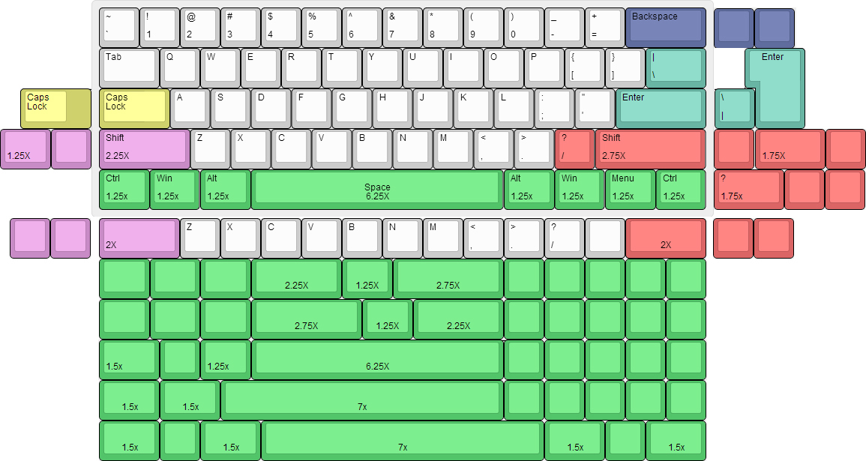

## Sources

* <http://qmkeyboard.cn>
* <http://github.com/qmk>
* <http://keyboarddiy.taobao.com>

## Features

1. Multiple Layouts (including arrow keys)
2. Multiple Backlight Levels
3. Different RGB underglow options/settings
4. N-key/6-key rollover (swappable)
5. Programmable with up to 15 layers of different macros
6. Easily programmable, combinations of layouts are endless!
7. One key can fire many keys in a macro
8. QMK can be upgraded at your convenience
9. Open source!

## Quick Layout Reference

### Layer 0

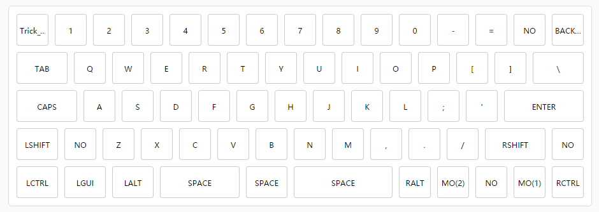

### Layer 1

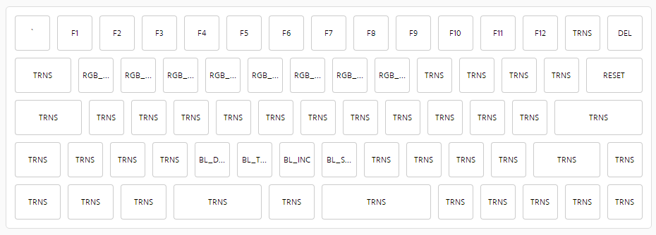

### Layer 2

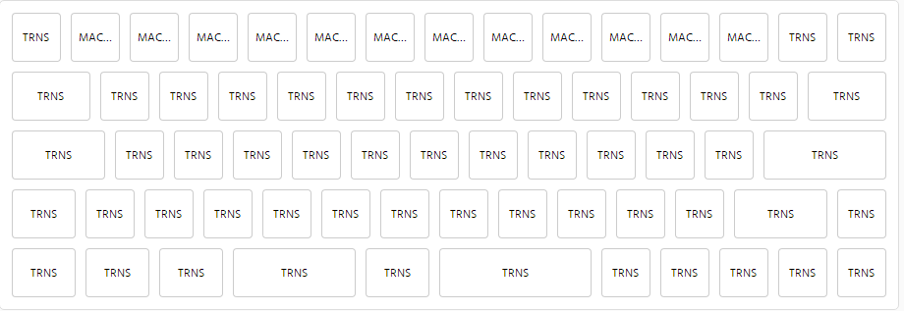

### Layout Instructions

* Trick Esc: SHIFT+ESC=`
* MO(1): Press and hold for layer 1 (similar to the function key in other 60%s)
* MO(2): Press and hold for layer 2
* NO: Ignore this key, typically used in layout with a split key – I will make sure that the key is not in use when keys are not split.
* MO(1)+Q,W,E,R,T,Y,U,I: RGB underglow controls – Q: on/off, W: change pattern, ER: add/subtract color, TY: add/subtract saturation, UI: brightness controls
* MO(1)+CVBN: Backlight controls – V: on/off, C: brightness down, B: brightness up, N: breathing control
* MO(1)+Backspace: DEL
* MO(1)+Comma(,), Period(.): Volume down/up
* MO(1)+\: RESET, enter bootloader mode
* MO(1)+Numbers [1,2,3,…0], +, -: F1-F12
* MO(2)+ Numbers [1,2,3,…0], +, -: Layers 1-12

### Boot Magic Key Combinations (Press these BEFORE the board is connected to the computer)

* **Space+ESC:** EEPROM is not used, default settings used for boot
* **Space+Backspace:** Clear settings stored in EEPROM, flash to default settings
* **Space+B:** Enter Bootloader mode
* **Space+LCtrl:** Switch Ctrl and Capslock, reconnecting to computer reverts change to default
* **Space+Capslock:** Change Capslock to Ctrl, reconnecting to computer reverts change to default
* **Space+LAlt:** Switch LeftAlt and LGui
* **Space+RAlt:** Switch RightAlt and RGui
* **Space+LGui:** Remove LGui functionality, reconnecting to computer reverts change to default
* **Space+Grave:** Switch Grave(`) and ESC(Mac)
* **Space+Backslash(\):** Switch Backspace and Backslash(\)
* **Space+N:** N-key rollover, reconnecting to computer reverts to 6-key rollover
* **Space+Numbers[0-9]:** Change the default layer to the specified number. If the default layer is not recoverable, try resetting with **Space+Backspace**
* Using BootMagic could lead to unforeseen abnormalities and changes in layers – if this happens, please use **Space+Backspace** and/or **Space+ESC** to reset to normal.